# ASP.NET MVC – Exam – October 2013

## Ticketing System in ASP.NET MVC

You are assigned to design and implement a **Ticketing System** where visitors (without authentication) should be able to **view most commented tickets**, as well as to **register** and **login** in the system. Registered users (after login) should be able to **view, comment, search and** **send tickets (e.g. bug reports)**. **Administrators** should have full **CRUD** operations on **categories** and **comments**.

The system should be implemented as a server-side web application in ASP.NET MVC 5.

### Ticketing System Data Layer (20 points)

* Use **Entity Framework** as ORM engine and **MS SQL Server Local DB** as database storage engine.

2 points

* **Repository pattern and Unit of Work** – the data layer should be implemented with repository pattern and unit of work.

7 points

Design a simple data layer to hold **users**, **categories, tickets,** and **comments**.

* Each **user** has **username, password and points**. The password should be stored in the DB encrypted (not as clear text).

1 point

* + The user’s **points** are by default 10 and for each reported ticket users receive 1 points.

1 point

* + Use the **ASP.NET Identity** system to keep the users and their encrypted passwords.

1 point

* **Categories** have **name** (mandatory) and hold a **set of tickets**.

1 point

* Each **ticket** has mandatory **author** (user), **category, title, priority** (low, medium (default value), high) andoptionally **screenshot URL** and **description** (string, no html allowed). Tickets also have a set of **comments**.

3 points

* Each comment has **user, ticket** and **content**.

1 point

* Fill some **sample data** in the DB to simplify any further testing.

2 points

* Your **project should run after "copy/paste" deployment**, without changing connection strings or other settings. You may use code first, model first or database first approach to access your data from Entity Framework.

1 point

### Ticketing System ASP.NET MVC Application – Common Features (16 points)

* **Layout** – design an ASP.NET MVC Layout page to reuse the common page elements like headers and footers and navigation in all other pages in the project.

2 points

* In the **navigation** when user is not authorized add link only to the home page, register and login pages.

For registered users add link for adding a new ticket and to tickets list.

For administrators add sub-menu for every administration available.

3 points

* + Use **Kendo UI Menu** for the navigation.

2 points

* **Configure the ASP.NET Identity System** to enable user management functionality (login / logout).

2 points

* + The username should be between 6 and 16 characters long.

2 points

* **Error handling** – in case of error (e.g. DB connection lost, incorrect request, etc.), an appropriate error message should be displayed. You are free to decide how exactly.

2 points

* **User interface (UI)** – the user interface should be the same as in the given images. Use bootstrap properly. The UI of the administration pages is not important.

3 points

### Ticketing System ASP.NET MVC Application – Public Area (15 points)

* **Home page** – at the application start page display the 6 most commented tickets. Display the title of the ticket, the name of the category, the name of the author and the number of comments. Show a link to the tickets details page.

6 points

* + **Cache** the 6 most commented tickets for an hour ahead.

2 points

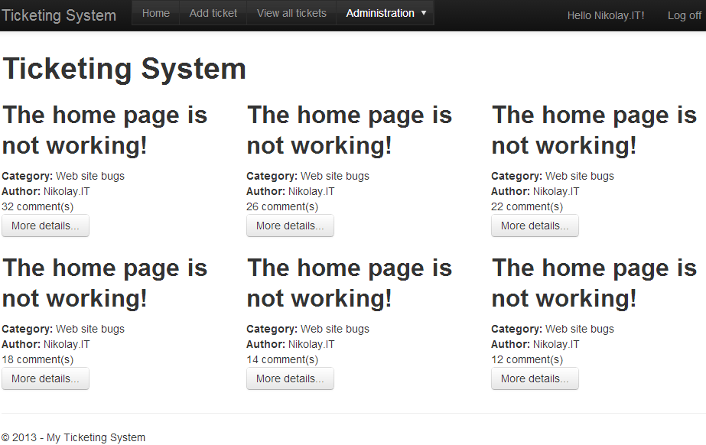

* **View ticket details** – clicking on a ticket from the start page should display all **ticket details** (title, description, priority, author, screenshot image and category) on a separate page. Display all **comments** for the ticket (no paging is required). The optional fields should not be displayed if not available.

7 points

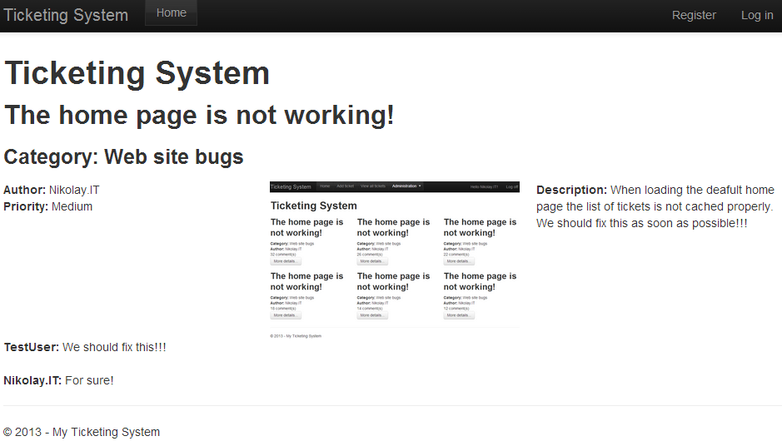

### Ticketing System ASP.NET MVC Application – User Area (34 points)

* **Registered users** should be able to **add tickets**. Write a form for adding a ticket.

Required fields: **category**, **title** and **priority**. The **screenshot URL** and **description** are optional.

Use MVC build-in client-side unobtrusive validation and server side validation.

4 points

* + The **author** of the ticket should be the currently logged user. After adding the ticket, also add 1 point to the user’s points.

1 point

* + Create drop down lists for the category and the priority (Kendo UI DropDown is not required).

2 points

* + Ticket’s title should **not** contain the word “bug” in it. Validate it with **custom validation attribute**.

3 points

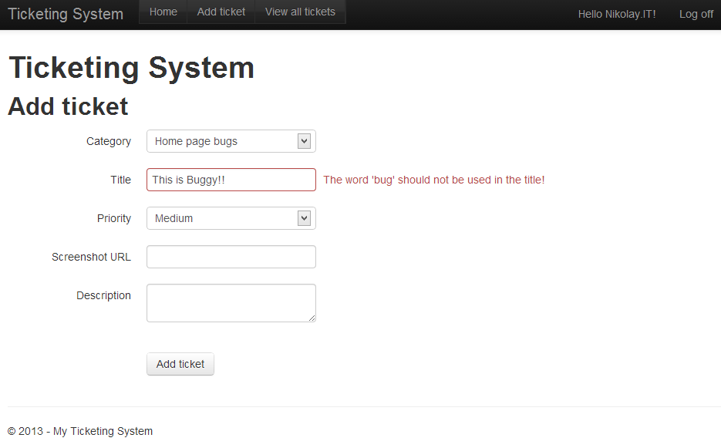

* **List page** – registered users (after login) should be able to see a list page with all the tickets. Display only **title**, **category**, **author** and **priority**.

5 points

* + Use **Kendo UI ListView** and custom template

2 points

* + Use server side paging (page size 5).

3 points

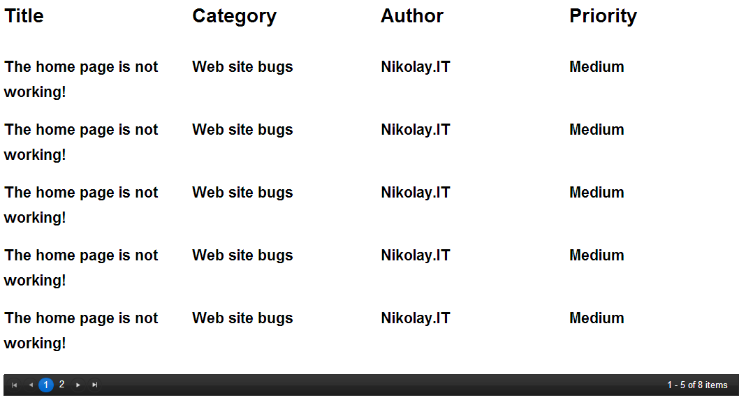

* **Commenting on tickets** – Registered users can **comment** the tickets in their details page.

4 points

* + **Commenting** should be done with **AJAX** updating the information without refreshing the page.

3 points

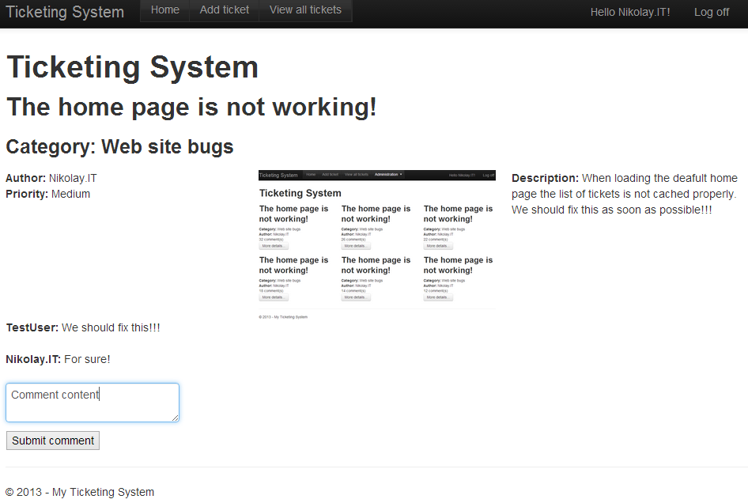

* **Search** – at the **List** **page** a category filter drop down and “Filter button” should be displayed.

In the drop down list there should be an empty option. If the empty option is selected, the search should not filter results by category.

4 points

* + Use **KendoUI DropDown** list for the category filter.

3 points

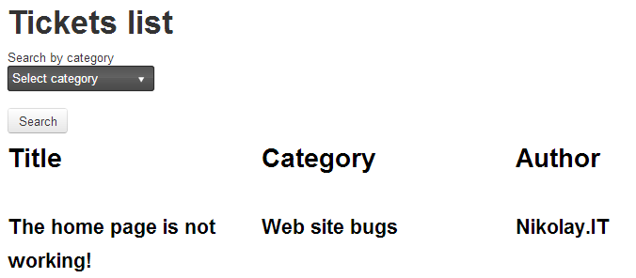

### Ticketing System ASP.NET MVC Application – Administration Area (15 points)

* **Create / edit / delete categories** – successfully logged-in administrators should be able to create / edit / delete ticket’s categories.

3 points

* + When a category is deleted all its tickets and their comments are deleted as well.

2 points

* + Use **Kendo Grid** with server side paging, sorting and filtering for the categories administration.

5 points

* **Edit / delete comments** – successfully logged administrators should be able to edit and delete comments. Use scaffolding.

3 points

* + Administrators should not be able to add comments. Only users should be able to add comments in the system.

1 point

* + When editing comments, the administrator should only be able to edit the content of the comment.

1 point

## Evaluation Criteria

The evaluation criteria include: correct and complete fulfillment of the requirements; good technical design and appropriate use of technologies; high-quality code (correctness, readability, maintainability).

To pass the exam you need to gain at least **70 point** (out of 100 point total).

## Other Terms

During the exam you are allowed to use any teaching materials, lectures, books, existing source code, and other paper or Internet resources. Direct or indirect communication with anybody in class or outside is forbidden. This includes but does not limit to technical conversations with other students, using mobile phones, chat software (Skype, ICQ, etc.), email, forum posts, etc.

## Exam Duration

Students are allowed to work up to **8 hours**.